**NAME** :- Manish Shashikant Jadhav

**UID** :- 2023301005.

**BRANCH** :- Comps -B. **BRANCH:** B.

**EXPERIMENT 4: To count number of letters in a string and to reverse the string.**

**SUBJECT** :- CAO (COMPUTER ARCHITECTURE AND ORGANIZATION)

**TOPIC 1** :- TO COUNT NUMBER OF LETTERS IN A STRING.

**CODE** :-

data segment

str1 db"MANISH","$"

data ends

code segment

assume cs:code,ds:data

start:

mov ax, data

mov ds,ax

mov cx, 00h

lea si,str1

mov dl,"$"

cld

abc:

mov bl,[si]

add si,01h

add cx, 01h

cmp bl, dl

jnz abc

sub cl,01h

mov dl,cl

add dl,30h

mov ah,02h

int 21h

mov ah,4ch

int 21h

code ends

end start

**OUTPUT** :-

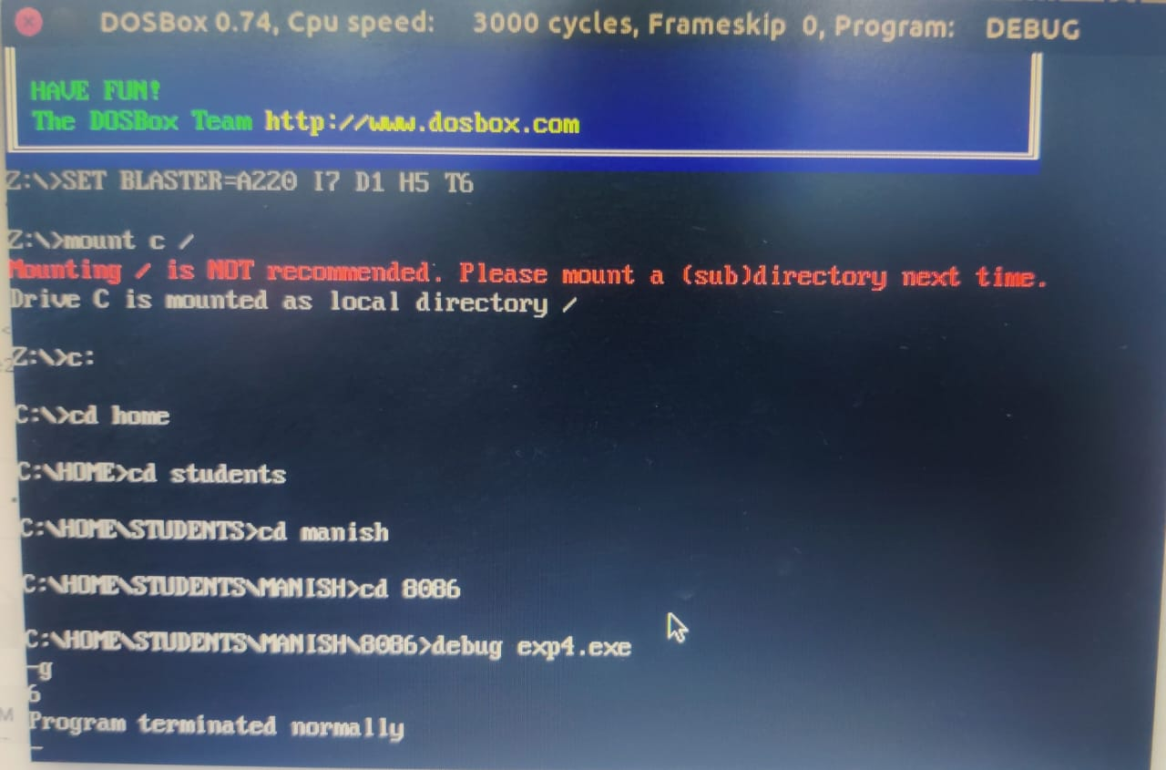

**TOPIC 2** :-TO REVERSE THE STRING.

**CODE** :-

data segment

str1 db"MANISH","$"

len equ $-str1

temp db 10 dup(0)

data ends

code segment

assume cs:code, ds:data

start:

mov ax, data

mov ds,ax

mov es,ax

mov si, offset str1

mov di, offset temp+(len-1)

mov cx,len

up:

cld

lodsb

std

stosb

loop up

mov ah,4ch

int 21h

code ends

end start

**OUTPUT** :-

